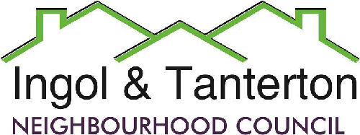

Gill Mason - Clerk and RFO

Email: [ingoltantertonnc@hotmail.co.uk](mailto:ingoltantertonnc@hotmail.co.uk)

**Agenda**

**A meeting of the Ingol and Tanterton Neighbourhood Council Finance & Asset Committee will be held on Wednesday 18th December 2024 at 6pm at Tanterton Village Centre.**

**Open forum**

1.To receive apologies.

2.To approve the minutes of the September Finance Committee Meeting.

3.To consider and approve the performance against budget update.

4.To consider the clerk’s hours, NALC pay agreement, consolidated payment and increase on payscale for the clerk.

5.To consider the request for an grant increase for Intact.

6.To consider the review of the budget for 2025/2026.

Press and public are welcome to attend.